Aryan Vats

BT22GCS208

Lab Assignment 5

Containerization and Application Deployment

Install SQL image:



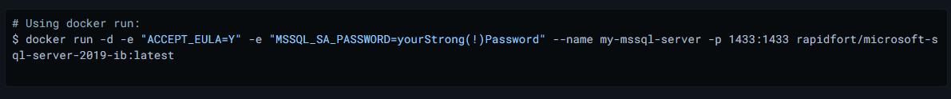

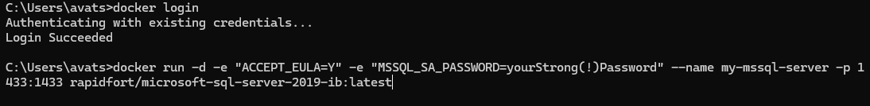

Checking the status of the containers:



Using Microsoft Azure for the sql queries

Create application server:

Allow application to communicate with database:

For activity log use logging service:

Creating login page

Create a folder called “Public” with HTML file in it and also update the app.js and docker files

HTML:

For login:

Start the server:

The server is running on port 3000.

The login page will look like this:

